Odoo v7 AvaTax Module User Guide

By Kranbery

Contents

**Initial Setup & AvaTax Configuration...p.3**

Install...p.3

Configure AvaTax API...p.3

*Adapter...p.4*

*Address Validation...p.4*

*System Calls...p.4*

*Countries...p.4*

*Tax Calculation...p.4*

Configure Exemption Codes...p.5

Product Tax Codes...p.5

Shipping Rate Configuration...p.6

**Configure Taxes...p.7**

Configure AVATAX Tax Type...p.7

**Product Category Configuration...p.8**

Create New Product Category...p.8

Configure Product Category Tax Code...p.8

**Product Configuration...p.9**

Create New Product...p.9

Configure Product Tax Code...p.9

**Customer Configuration...p.10**

Create New Customer...p.10

Configure Customer Address...p.10

Address Validation...p.11

Tax Exempt Status...p.11

**Customer Invoices...p.12**

Create New Customer Invoice...p.12

Compute Taxes with AvaTax...p.12

Validate Invoice...p.13

Register Payment...p.13

**Customer Refunds...p.14**

Initiate Customer Refund...p.14

Create Refund Ticket...p.14

Validate Refund...p.15

Register Refund Payment...p.15

**Sales Orders...p.16**

Create New Sales Order...p.16

Compute Taxes with AvaTax...p.16

Initial Setup & AvaTax Configuration

**Overview**

The purchase of AvaTaxERP connector software provides your organization with access to the AvaTax Calc service, including sales tax calculation for all US states and territories and all Canadian provinces and territories (including GST, PST and HST).

This guide includes instructions for the following elements:

Activating your organization’s AvaTax account and downloading the product

Entering your AvaTax credentials into your ERP Configuring your ERP to use the AvaTax Calc service Using AvaTax features within your ERP

* Note: It is recommended that you test the module before deploying in a production environment.

* Note: All changes to AvaTax settings must be done by a user with administrative privileges.

**Installation**

Download the AvaTax Module: <http://kranbery.com/avatax>

Extract the downloaded file

Upload the extracted directory your configured Odoo modules directory

* Uninstall any previous instances of the module before installing a new version of the module

Restart Odoo service

Login as Administrator

Navigate to: *Setup > Installed Modules > Search for AvaTax*

Click “Install” button

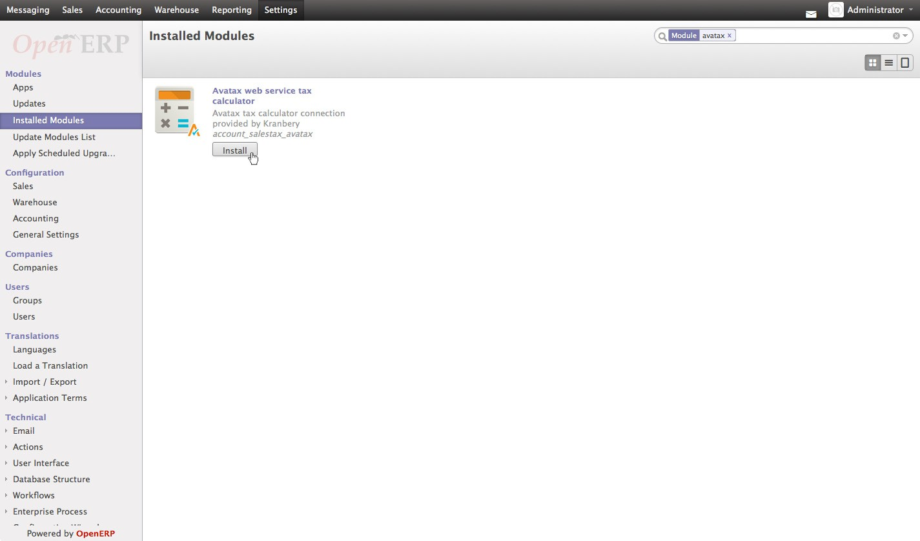

**Configure AvaTax API**

Navigate to: *Accounting > Configuration > AvaTax > AvaTax API*

Click “Create” button

Fill out the form with Company Code, Account Number and License Key provided to you by Avalara

Fill out the proper service URL provided to you by Avalara

* You may have two service URL’s: One for development/testing server and another for production transactions.

Click “Test Connection” button

Click “Save” button

You can further configure the module on this screen.

Other configuration options are:

**Adapter**

» Request Timeout - *Default is 300ms*

» Enable Logging

**Address Validation**

» Attempt automatic address validation – *Will perform automatic validation when performing tax computation. The other validation options (below) are not required and will be deselected but available.*

» Validate on save for customer profile *– Automatically attempts to validate on creation of customer profile update and creation. Last validation date will be visible and stored.*

» Force Address validation on customer profile save *– In the case validation for customer is required but not valid, the validation will be forced.*

» Return validation results in upper case *– validation results will return in upper case form.*

**System Calls**

» Order-level - All items on order are calculated as one transaction

» Line-level - Each item in an order is calculated, displayed and transacted separately

**Countries**

» Add or remove applicable countries

**Tax Calculation**

» Disable Tax Calculation

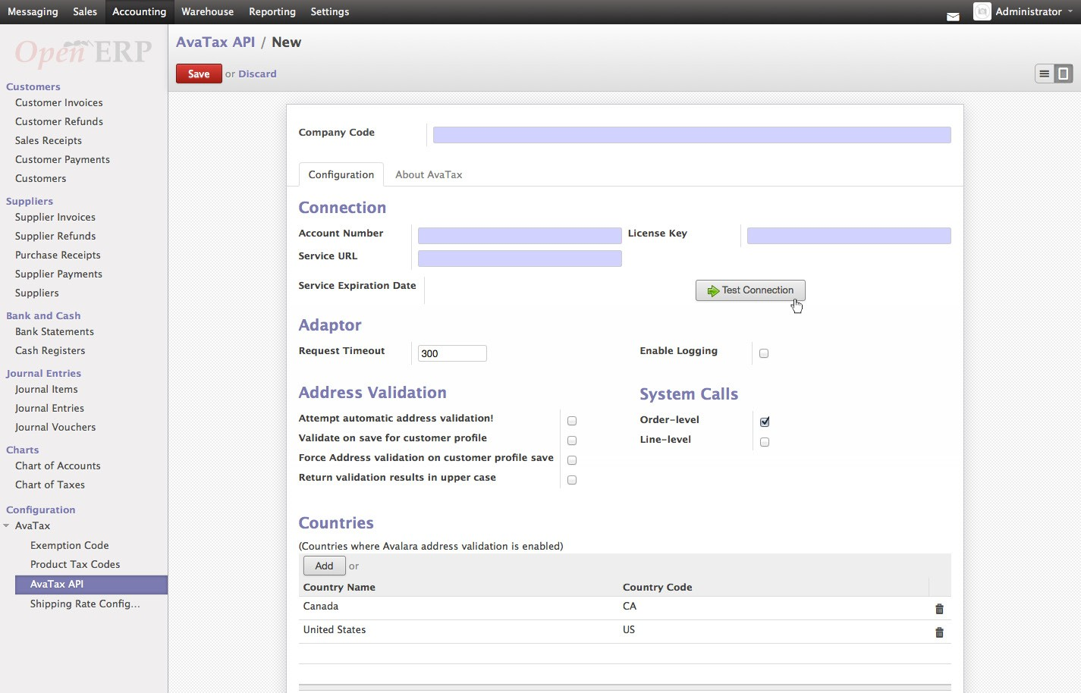

**Configure Exemption Codes**

Exemption codes are allowed for users where they may apply, e.g., Government entity.

Navigate to: ***Accounting > Configuration > AvaTax > Exemption Code*** The module is installed with sixteen (16) predefined exemption codes **Add, remove and modify** exemption codes

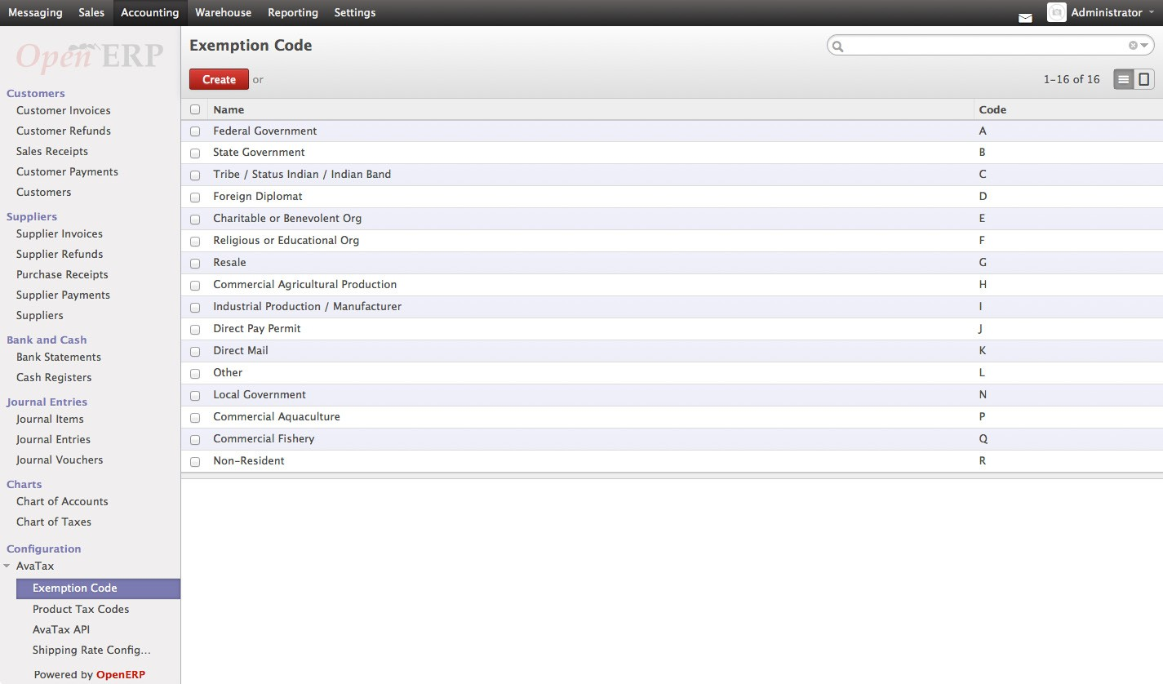

**Product Tax Codes**

Create product tax codes to assign to each product and/or product category.

Navigate to: ***Accounting > Configuration > AvaTax > Product Tax Codes***

**Add, remove and modify** product tax codes

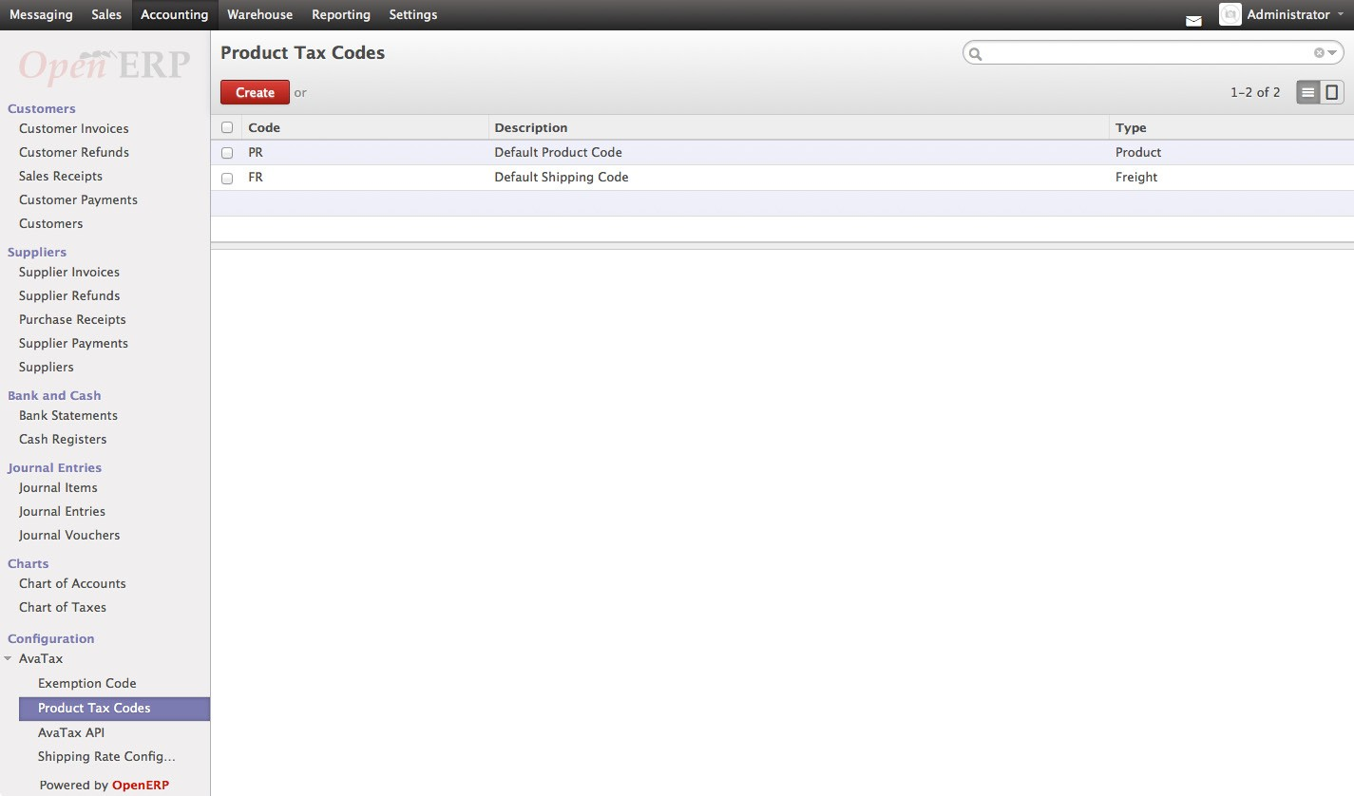

**Shipping Rate Configuration:**

Configure shipping rates to apply to each transaction/product.

Navigate to: ***Accounting > Configuration > AvaTax > Shipping Rate Configuration***

**Add, remove and modify** shipping methods and rates

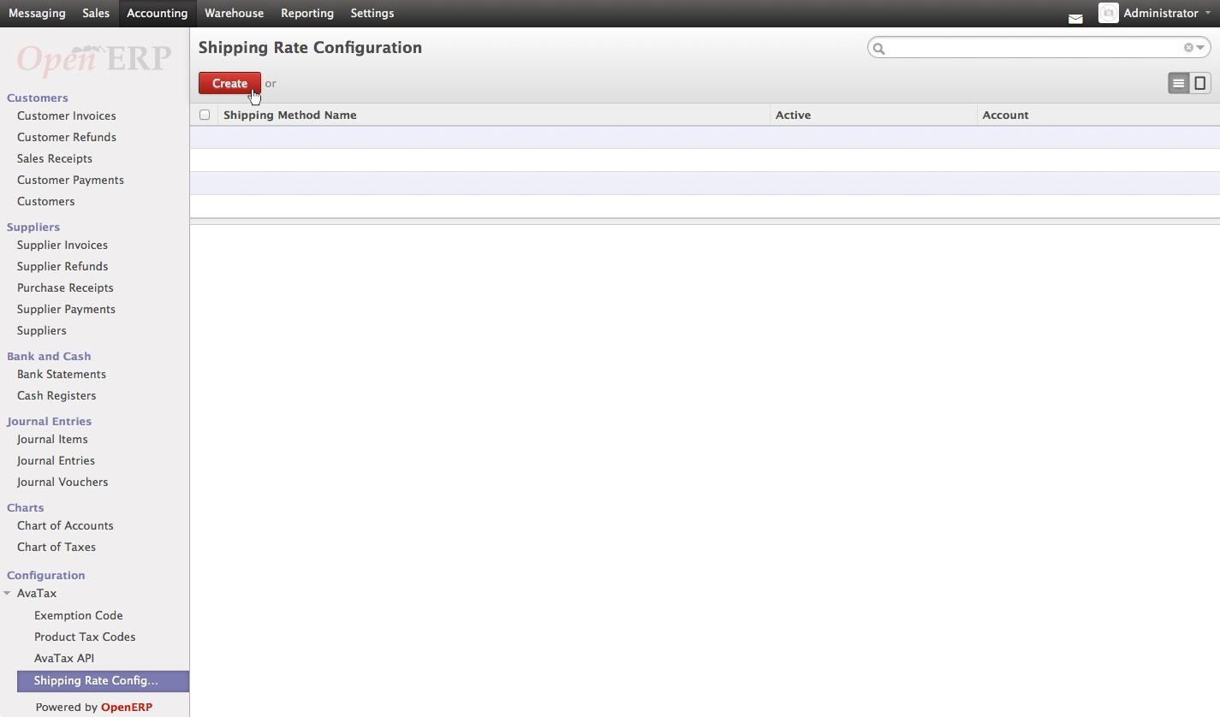

Configure Taxes

The AvaTax module is integrated into the Taxes of Odoo. “AVATAX” is automatically added as a type of Taxes to be applied. You can configure how ‘”AVATAX” integrates into the Odoo system.

Configure AVATAX Tax Type

Navigate to: ***Accounting > Taxes > Taxes***

Select AVATAX from the list view

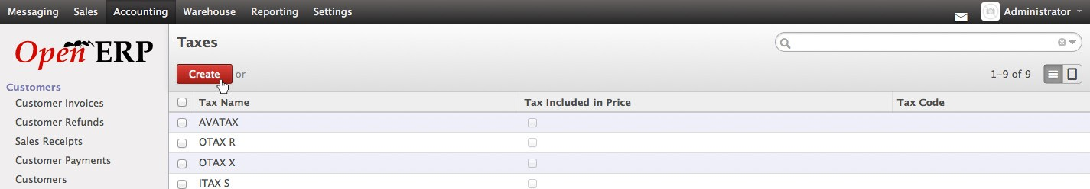

Click the **“Edit”** button

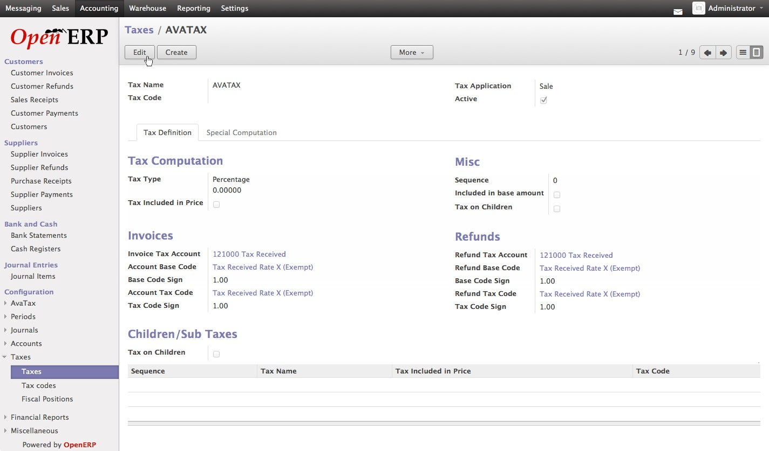

Configure the AVATAX Tax Type

Click the **“Save” button**

* Upon initial install the settings will be blank. The above image shows an example configuration.

Product Category Configuration

Odoo products are typically assigned to product categories. AvaTax settings can be assigned to the product category. The category default tax code will auto-populate when a product category is created

.

**Create New Product Category**

Navigate to: ***Sales > Configuration > Products > Product Categories***

Click **“Create”** button

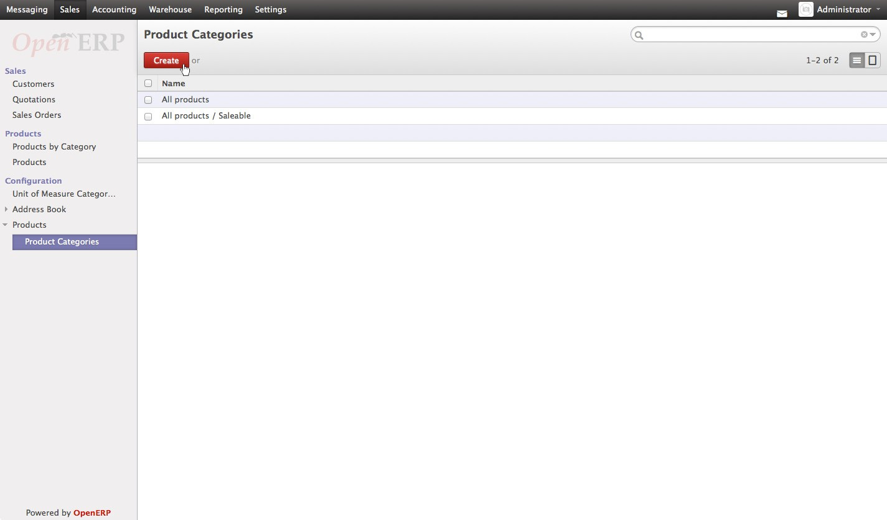

**Configure Product Category Tax Code**

Under **AvaTax Properties > Tax Code**, Select the desired Tax Code

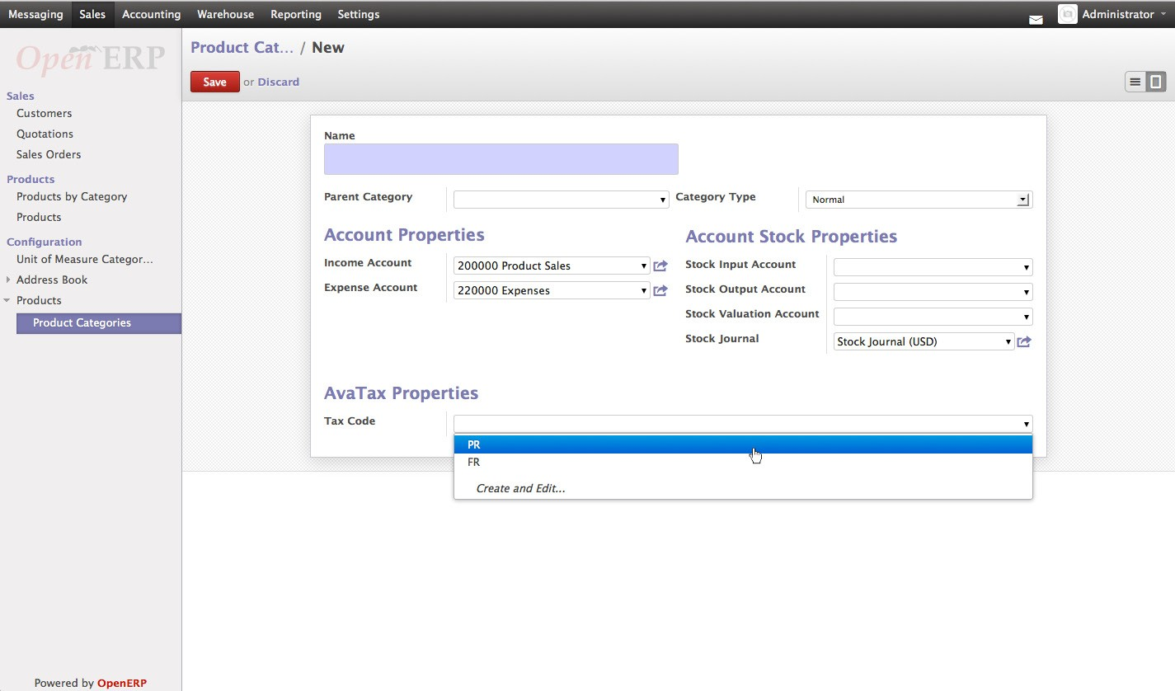

Click “Save” button

Product Configuration

Individual products default to the tax code assigned to its product category, however you can change the tax codes if necessary. Tax calculations for a specific product can be disabled as need.

Create New Product

Navigate to: ***Sales > Products > Products***

Click **“Create”** button

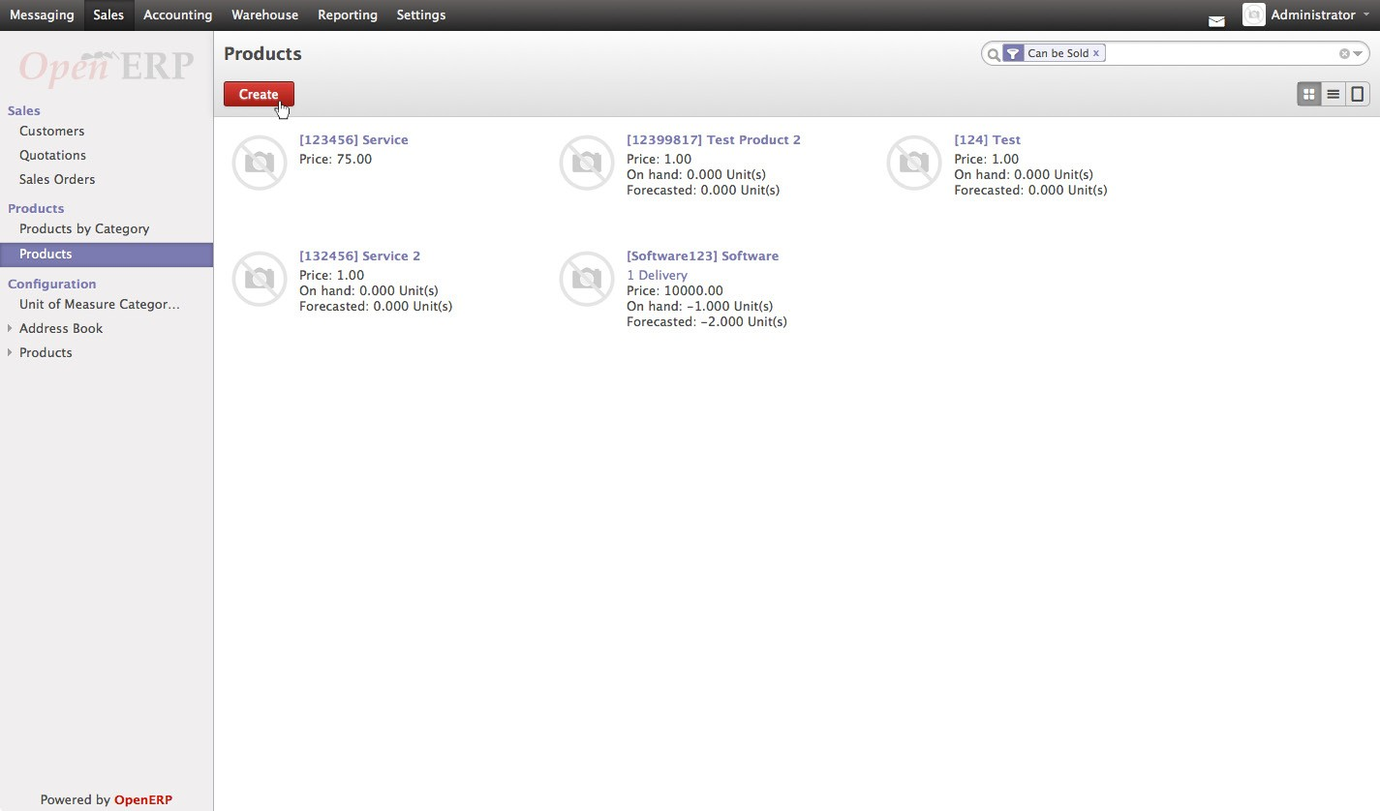

**Configure Product Tax Code**

Under Category, select a Product Category

Under AvaTax Properties, the Tax Calculation check box is checked by default

If you wish to change the Tax Code defined by the Product Category, do so under

**AvaTax Properties > Tax Code**

Click **“Save”** button

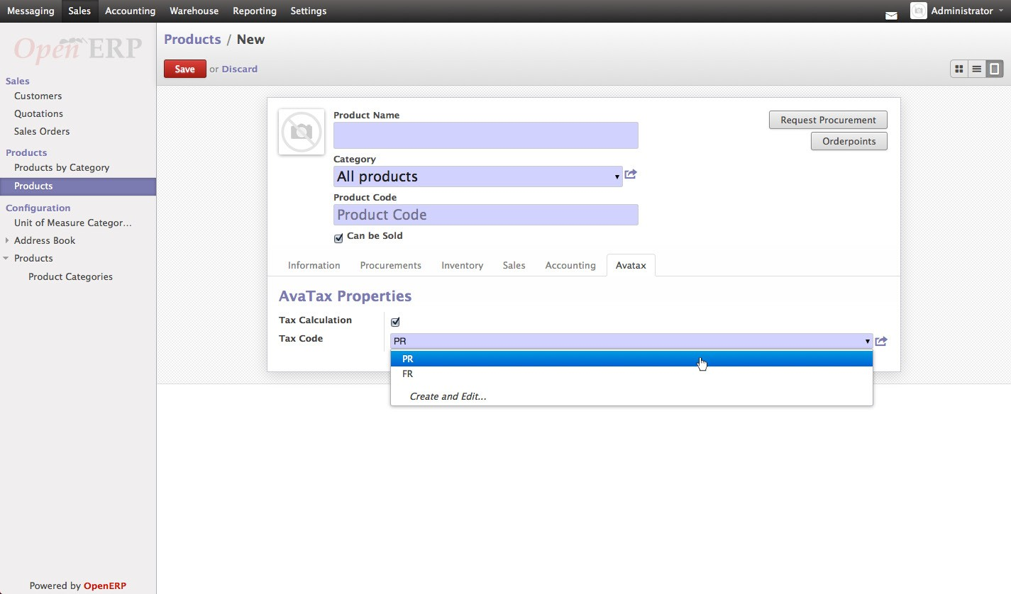

Customer Configuration

Properly configuring each customer ensures the correct tax is calculated and applied for all transactions.

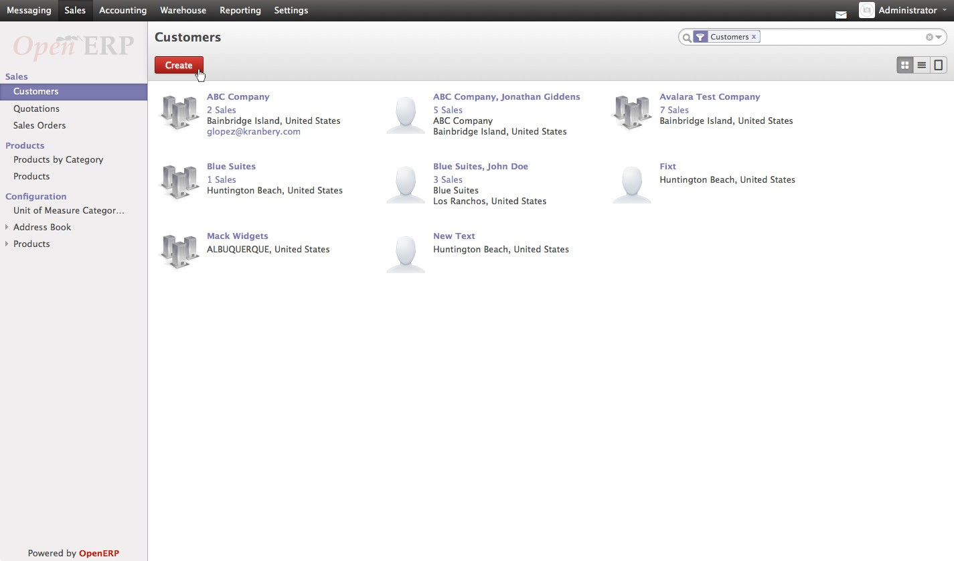

Create New Customer

Navigate to: ***Sales > Customers***

Click **“Create”** button

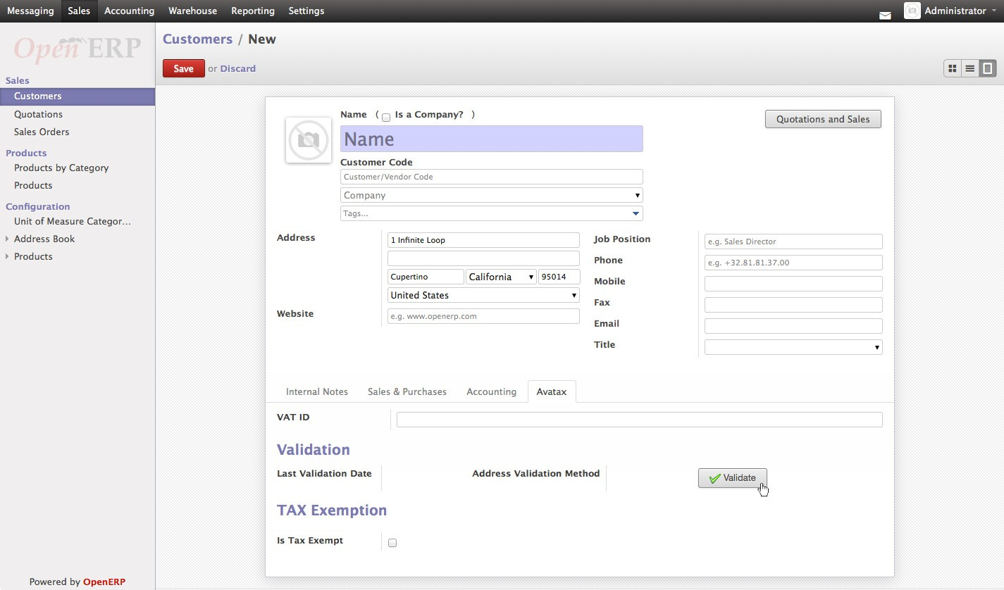

Configure Customer Address

Enter Customer Address Select the AvaTax tab

Click **“Validate”** button

**Address Validation**

AvaTax Module will attempt to match the address you entered with a valid address in its database. Click the **“Accept”** button if the address is valid

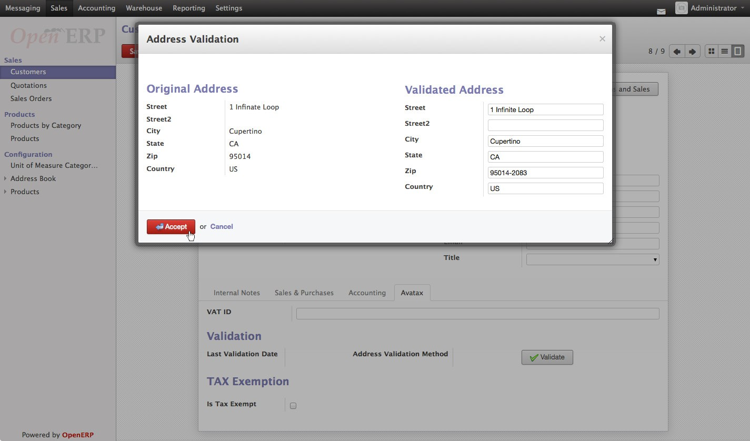

If the address is not found in the AvaTax database you can still continue and use the address you entered by clicking “OK” on the warning dialog box

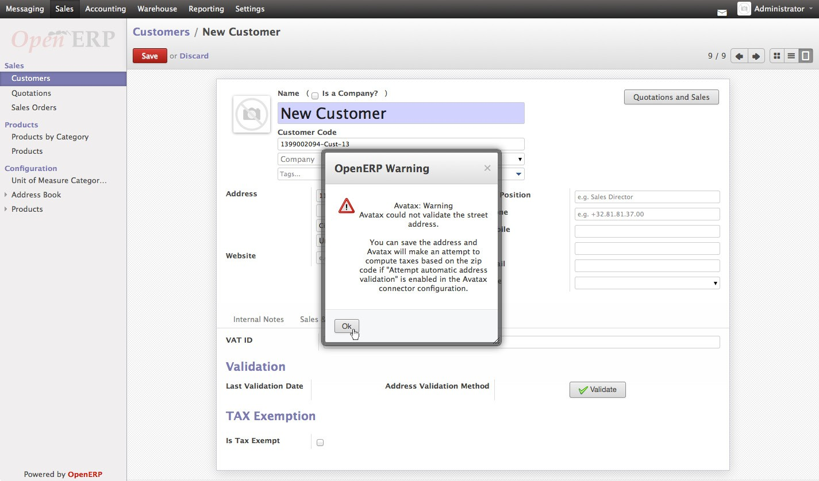

**Tax Exemption Status**

If the customer is Tax Exempt, uncheck the box Under **Tax Exemption > Is Tax Exempt**

Select the desired **Tax Exempt Code** from the dropdown menu

Customer Invoices

The AvaTax module is integrated into Customer Invoices and is applied to each transaction. The Transaction log in the AvaTax interface shows the invoice details and displays whether the transaction is an uncommitted or committed status. A validated invoice will show an “Uncommitted” and a paid Invoice will show a “Committed” status.

**Create New Customer Invoice**

**Navigate to: *Accounting > Customers > Customer Invoices***

Click **“Create”** button

**Compute Taxes with AvaTax**

Fill out the customer invoice as normal for Odoo You will note that under Taxes you should see **“AVATAX”** Click **“Compute Taxes”**

* Note: There is a “Compute” button at the top of the window as well as the “Compute Taxes” button under the subtotal section of the invoice window. Both button and link return a tax calculation.

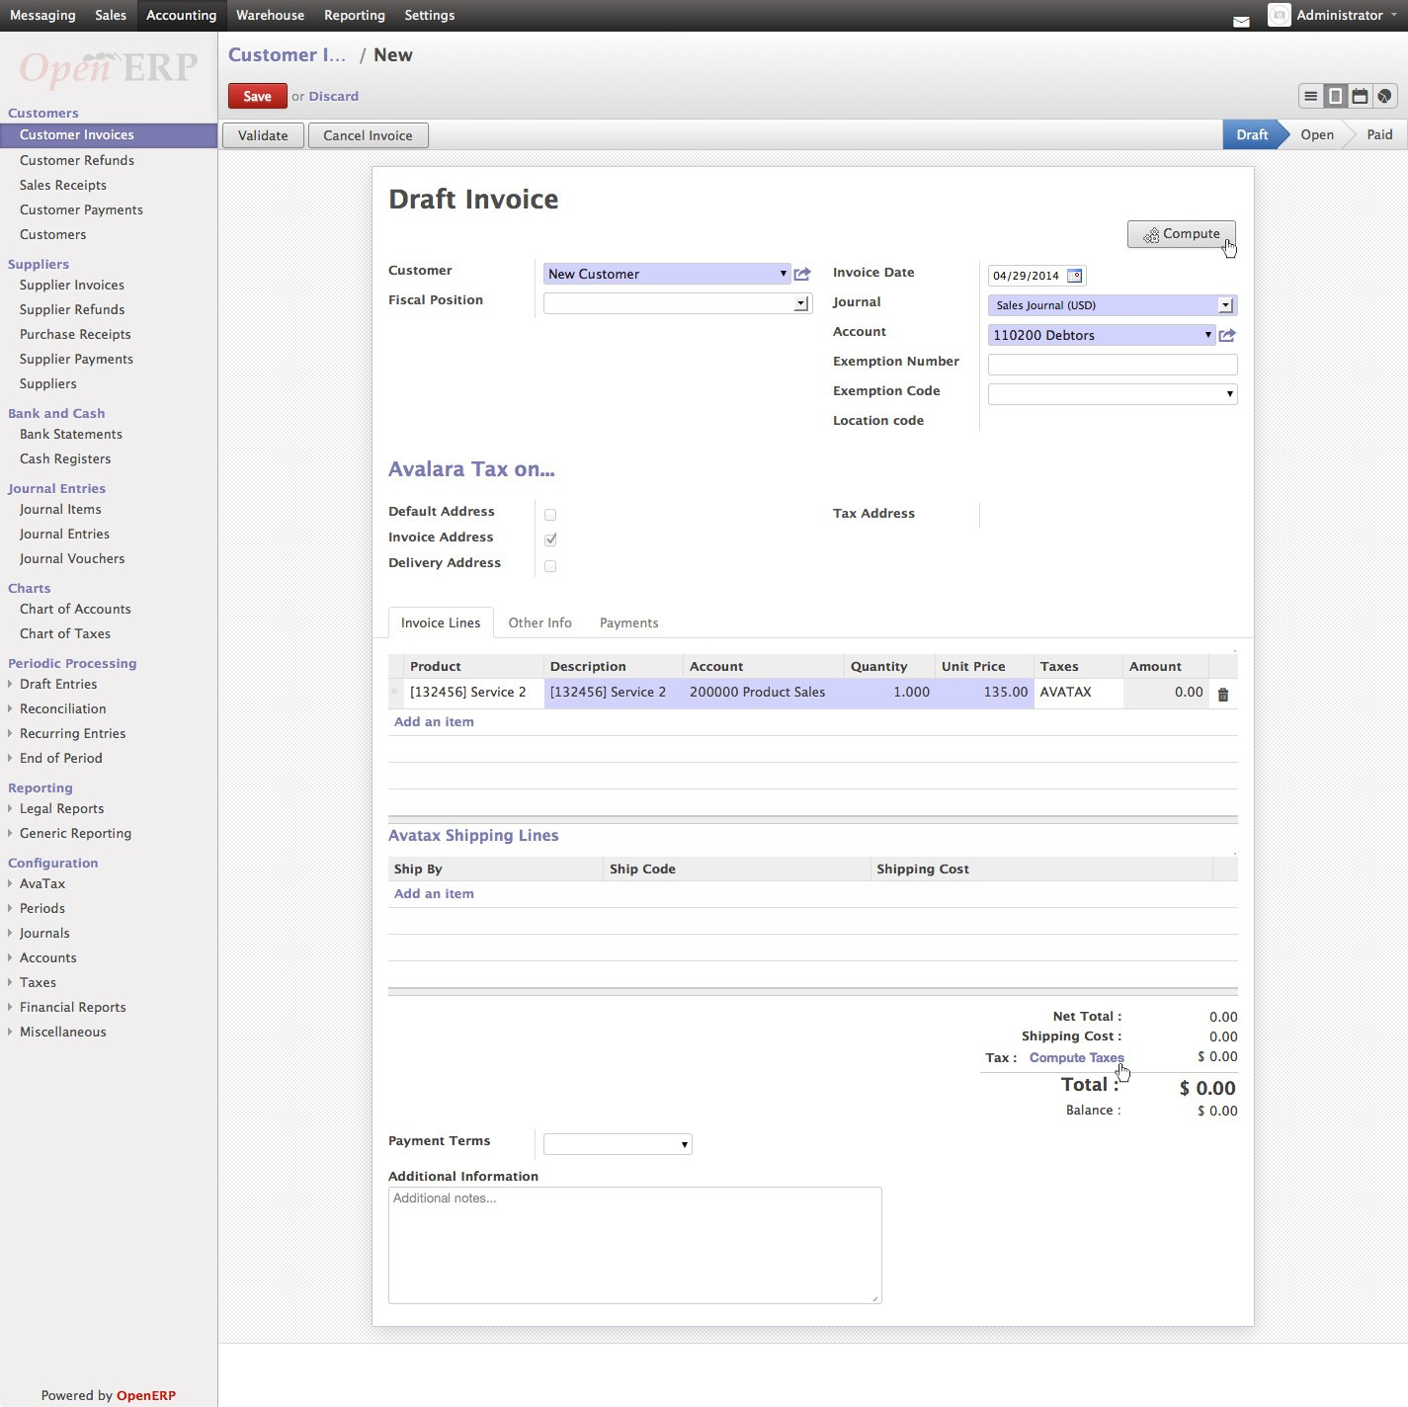

**Validate Invoice**

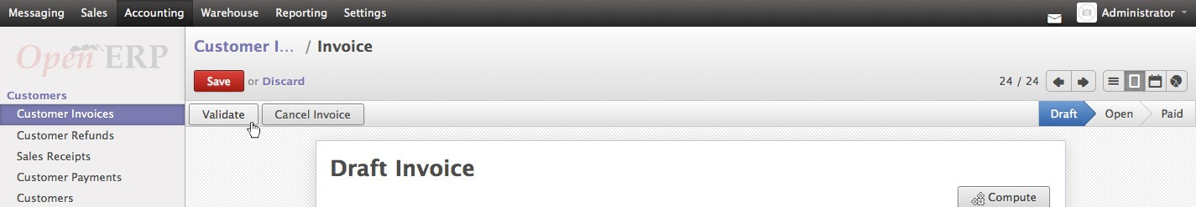

After the taxes have been computed click **“Validate”** button

**Register Payment**

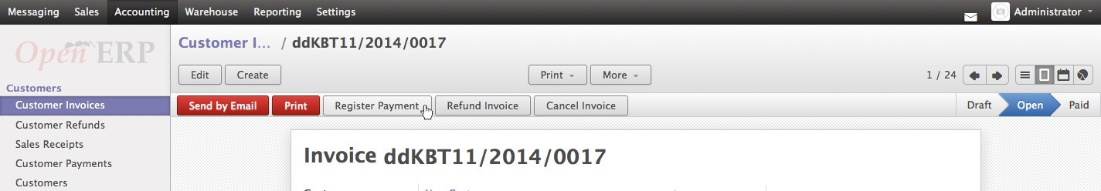

To complete the invoice click **“Register Payment”** button

Complete the Pay Invoice window

Click **“Pay”** button to finalize the Customer Invoice

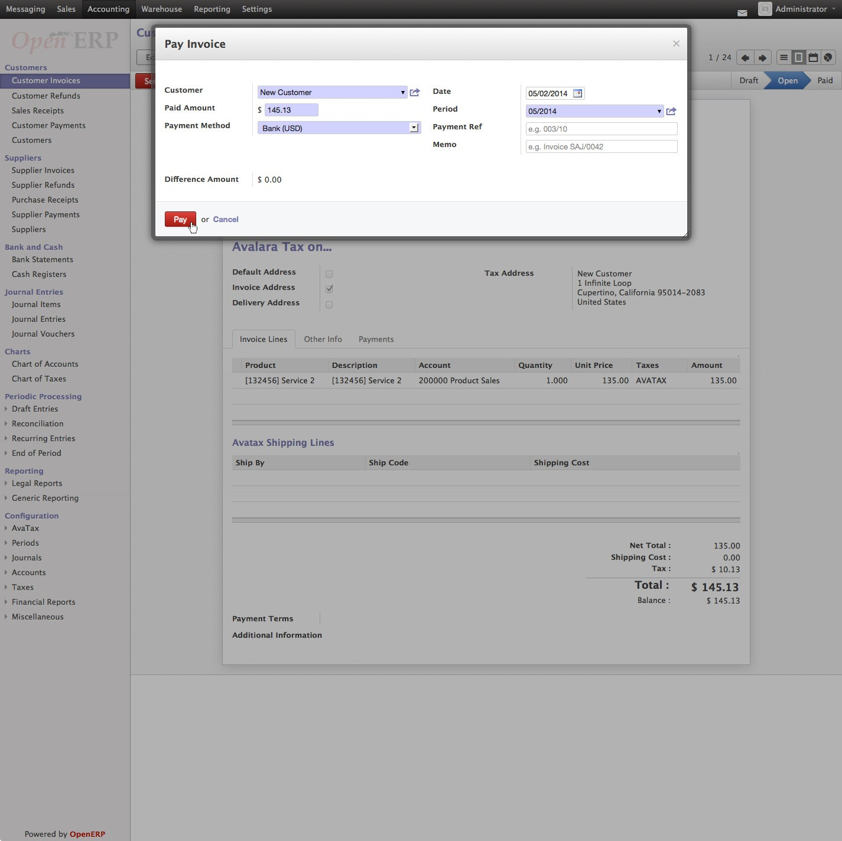

Customer Refunds

Odoo applies refunds as opposed to voids in its accounting module. As with customer Invoices, the AvaTax module is integrated into Customer Refunds and is applied to each transaction. Refund Invoice transactions will be indicated with a negative total in the AvaTax interface.

**Initiate Customer Refund**

Navigate to: ***Accounting > Customers > Customer Invoices***

Select the invoice you wish to refund

Click **“Refund Invoice”** button

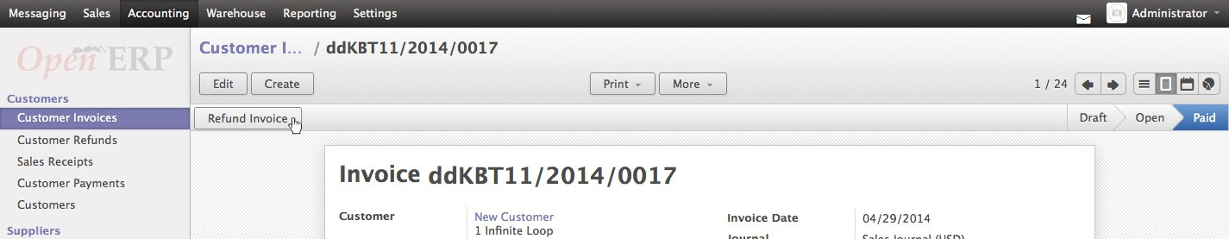

**Create Refund Invoice**

Under Refund Method select **“Create a draft refund”** from the dropdown

Click **“Create Refund”** button

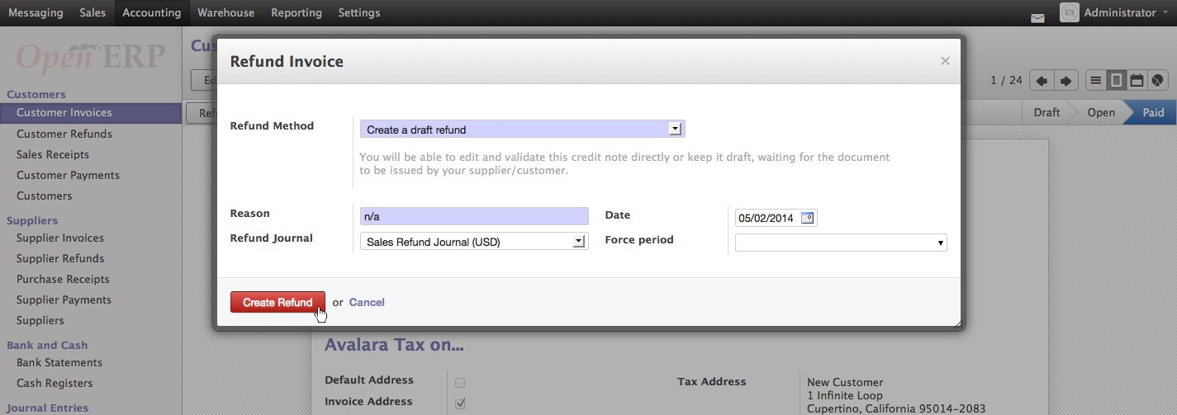

You will be taken to the Customer Refunds list view

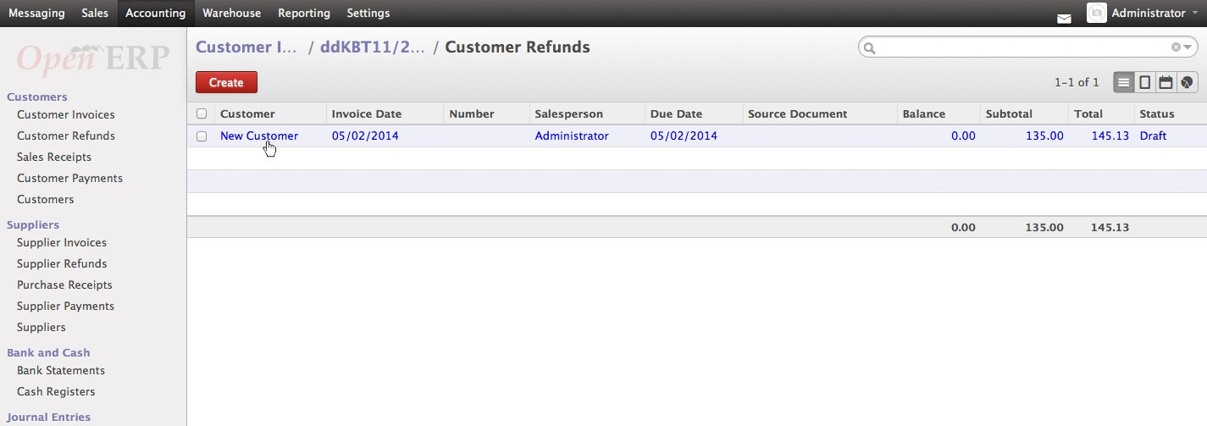

**Validate Refund**

Select the Customer Refund you wish to refund

Review the Draft Refund and click **“Validate”** button

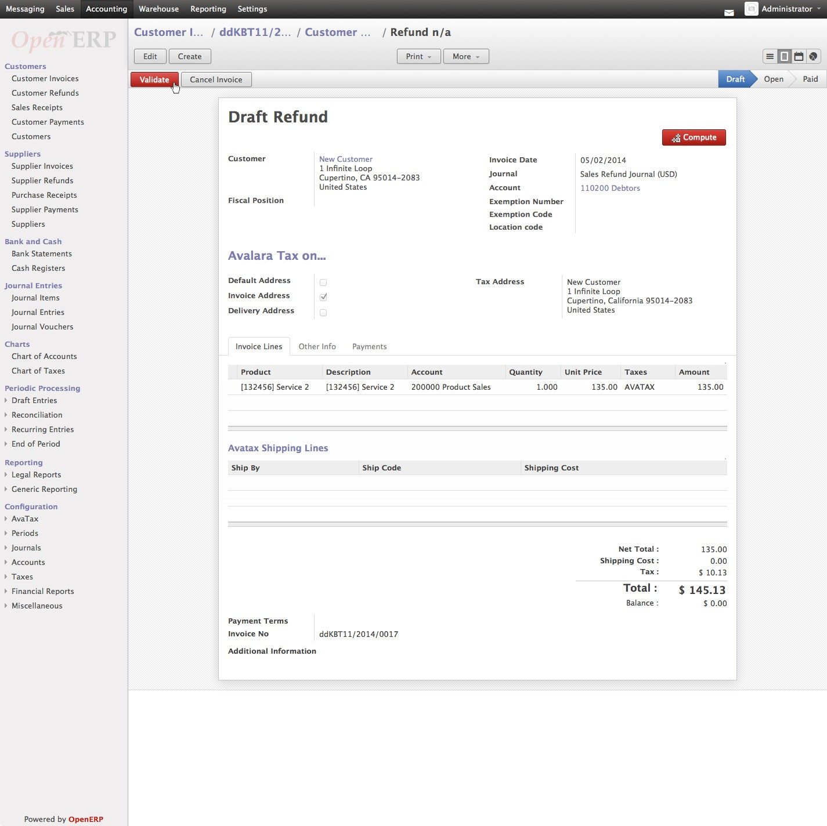

**Register Refund Payment**

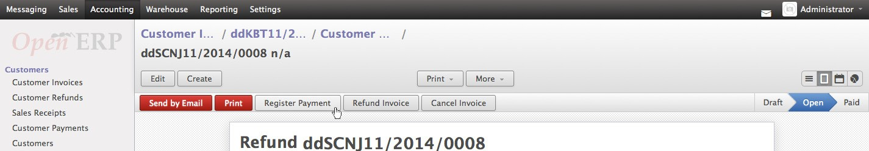

Click **“Register Payment”** button to complete refund

Complete the Pay Refund window

Click **“Pay”** button to finalize the Customer Refund

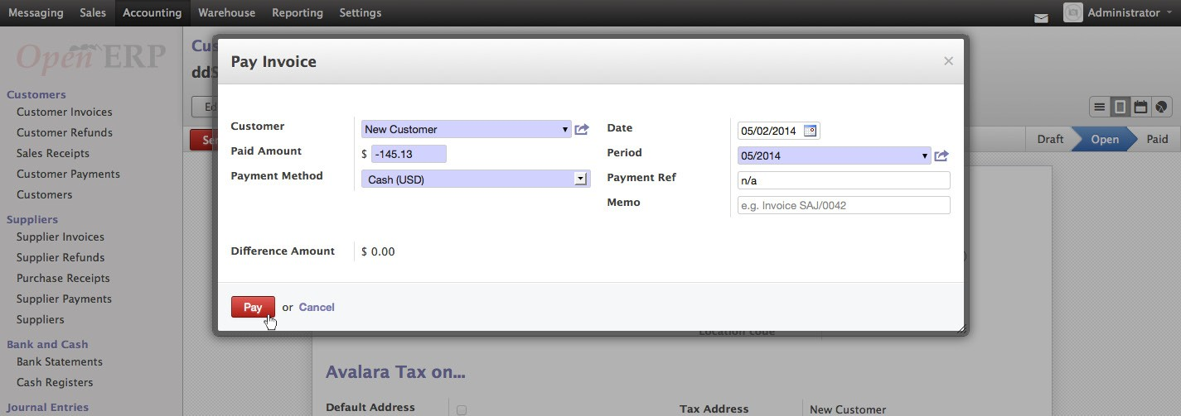

Sales Orders

The AvaTax module is integrated into Sales Orders and allows computation of taxes. Sales Order transactions do not appear in the in the AvaTax interface.

**Create New Sales Order**

Navigate to: ***Sales > Sales > Sales Orders***

Click **“Create”** button

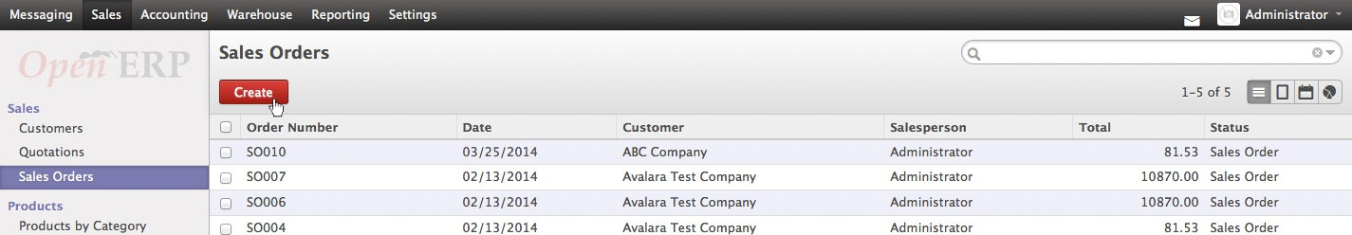

**Compute Taxes with AvaTax**

Fill out the customer invoice as normal for Odoo You will note that under Taxes you should see **“AVATAX”** Click **“Compute”** in the subtotal section of the page

